THE COMPANY ONSTAGE
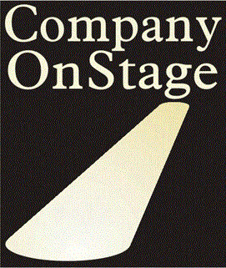
AUDITION FORM
Name: | Date:
Production(s) Auditioning For:
Role(s) Desired:
Would you be willing to accept another role? Yes: No
Please list any rehearsal or performance conflicts you have:

PERSONAL INFORMATION

Street Address:
City, State and Zip:
Phone(s):
Email:
M or F Height: Age Range: Ethnicity:
ACTING EXPERIENCE HIGHLIGHTS (or attach resume) : Resume Website:
Year | Role | Production | Theater/Production Co.

Special Skills (dancing, singing, juggling, musical instruments, accents, yodeling, etc.)
Are you interested in volunteering for any of the following or learning a new skill (please circle areas of interest)? Directing / Stage Management / Light and Sound Operation / Guest Hospitality, Concessions, Box Office / Costume Design, Construction, Coordination / Marketing, Media, Press, Promotions / Set Design, Set Dressing, Construction, Carpentry / Development & Fundraising / Event Coordination / Other: ______________________________________________________________________________
New to COS? How did you learn about us?:
Anything else you want us to know about you?
THANK YOU! We appreciate your being interested in COS and taking the time to audition for us today.
Please use back of form for additional information.

